**Project Submission Report**

**1. Project Overview**

**Project Name:** Unicom TIC Management System (UMS)

* **Key Features Implemented:**
  + User authentication and login management.
  + Course and exam controller modules for managing academic data.
  + GUI interface developed using Windows Forms (WinForms).
  + Modular structure with controller-based architecture.
* **Technologies Used:**
  + C# with .NET Framework
  + Windows Forms for GUI
  + Visual Studio Solution (.sln)
  + Entity Framework (based on packages.config references)
  + App.config for application configuration
* **Challenges Faced & Solutions:**
  + **Form Design Complexity:** Used Designer.cs partial classes to modularize form layout and business logic.
  + **Login Security:** Structured LoginController to handle user credential verification securely.
  + **Code Organization:** Split into separate folders (e.g., controllers) to maintain MVC-style separation.

2. Code Samples (Screenshots)

LoginController.cs

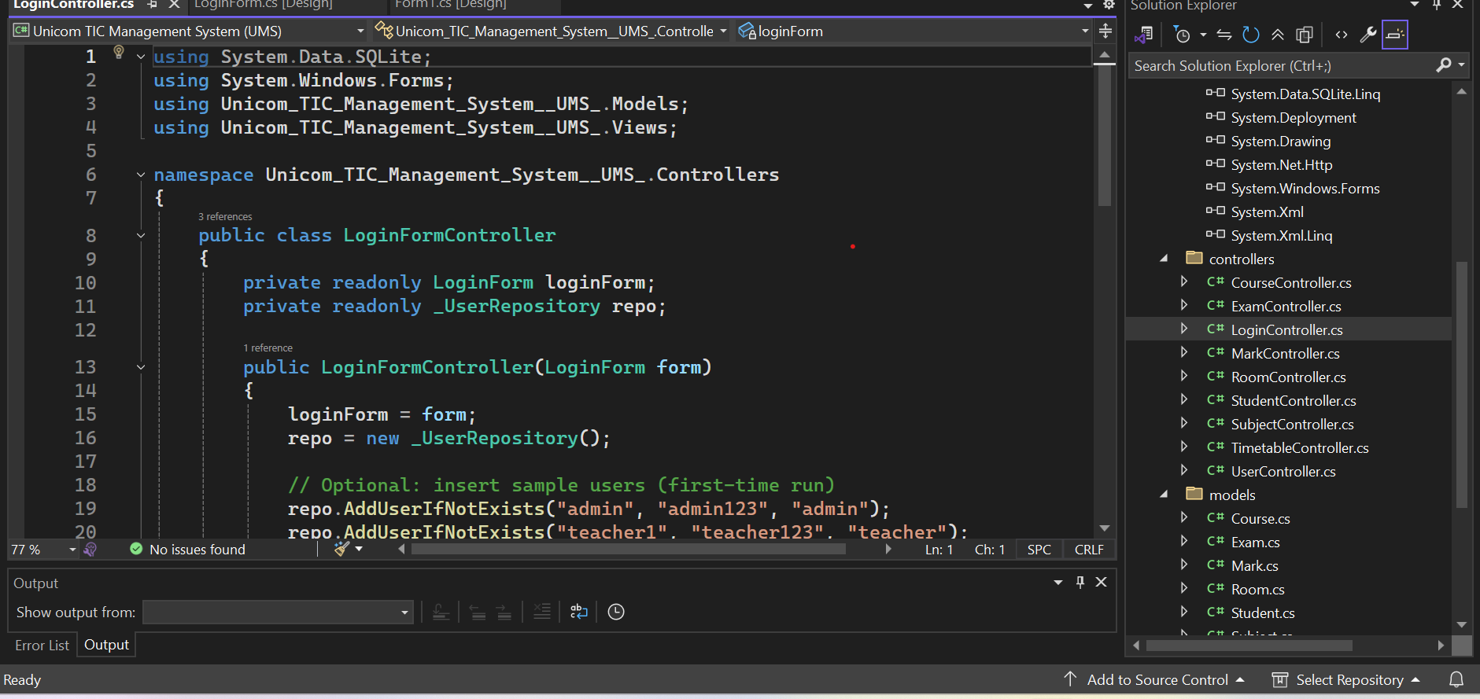

LoginForm

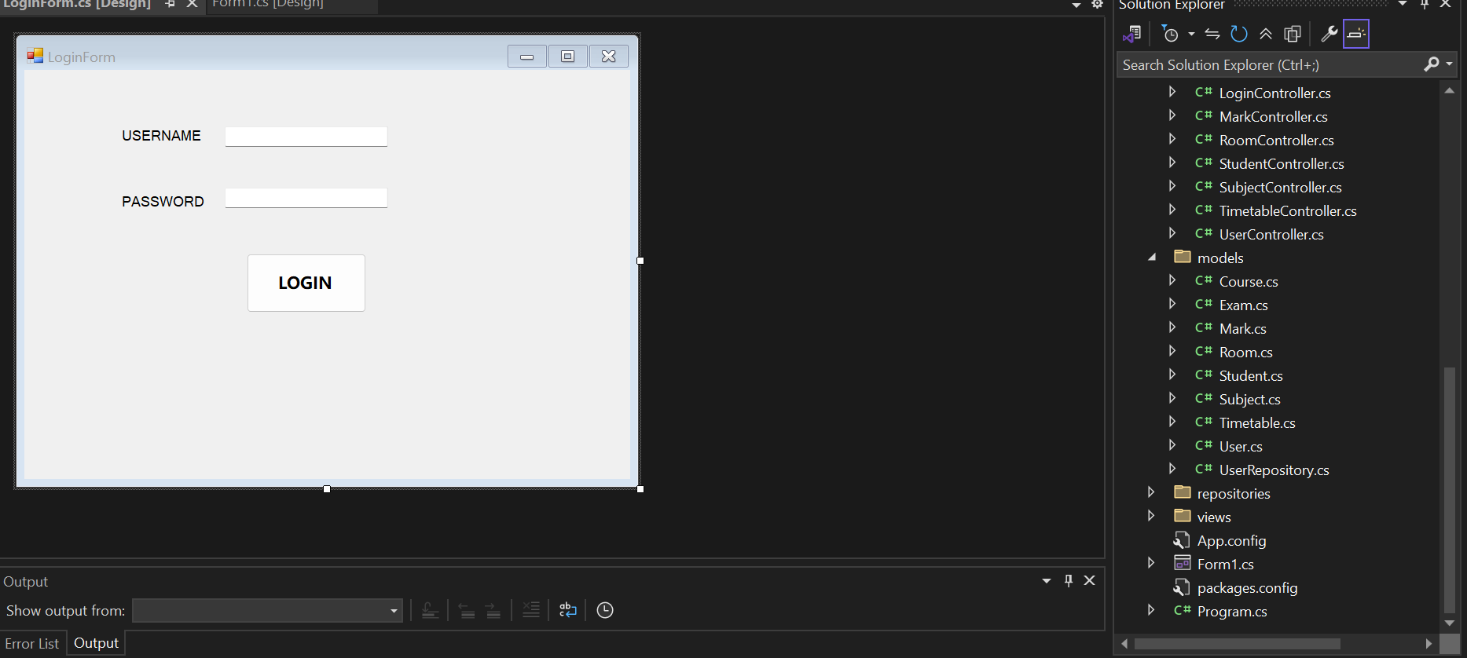

CourseController.cs

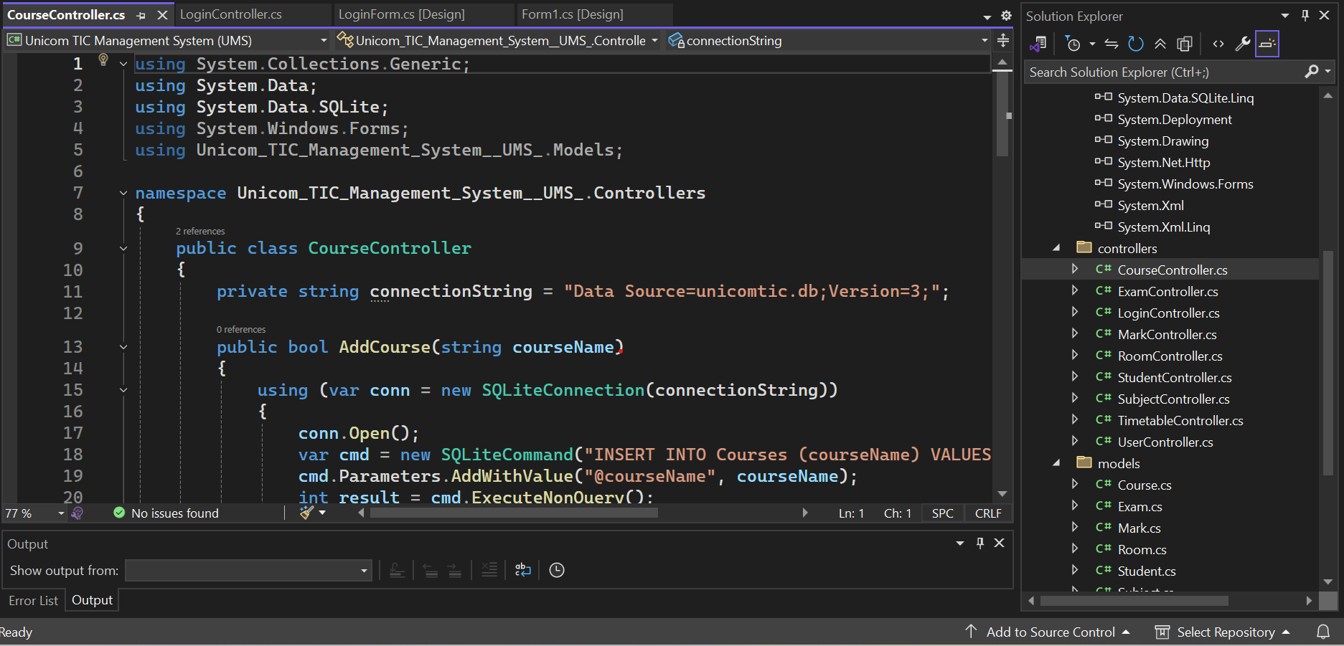

ExamController.cs

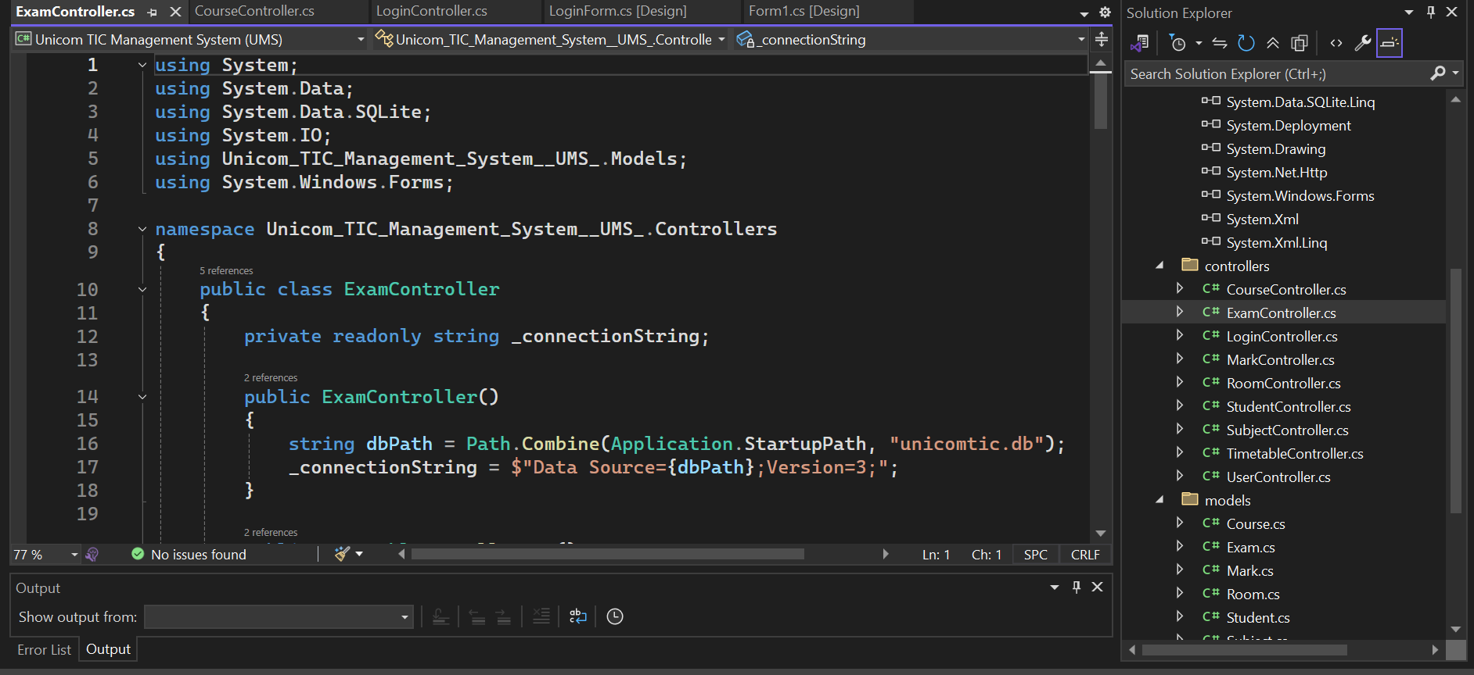

Program.cs

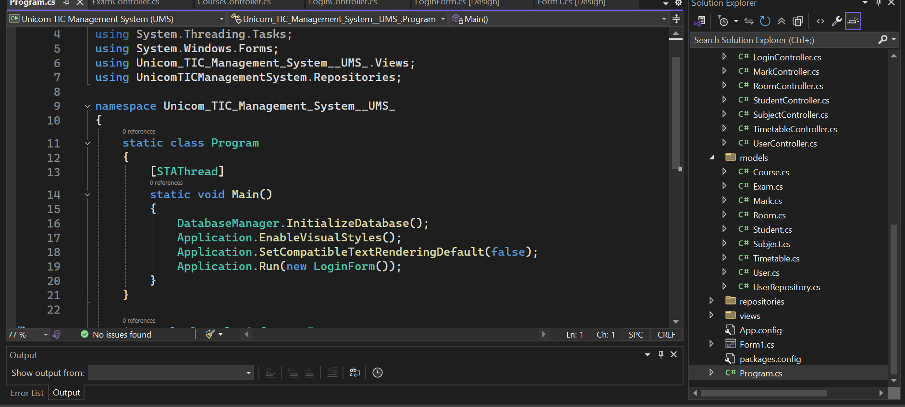

App.config

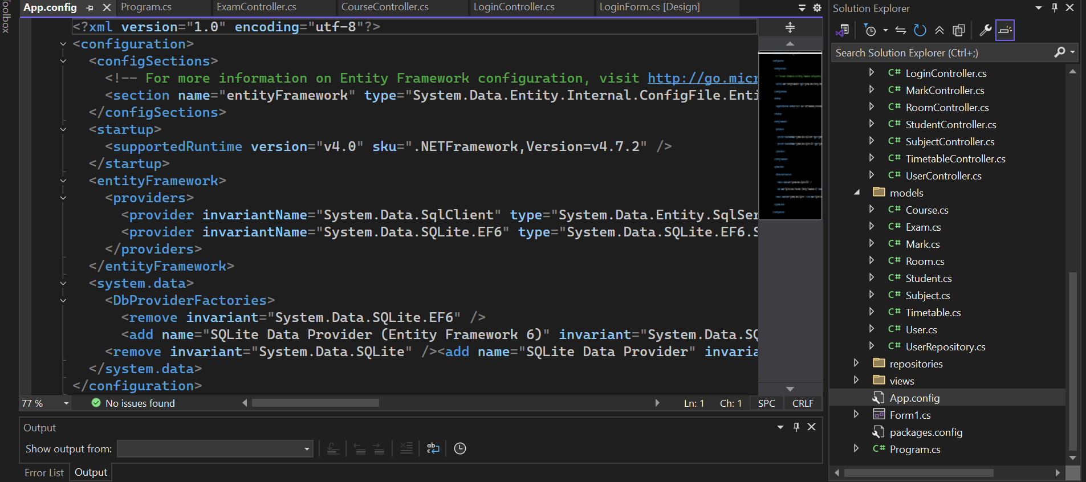

Solution Explorer

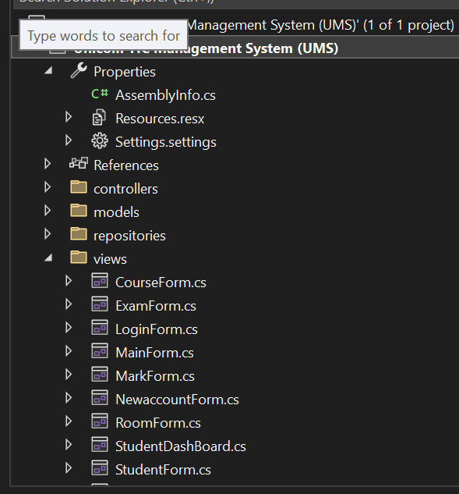

User Name and Password

